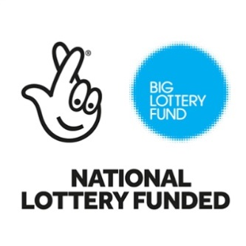
Holwell Village Hall Management Committee are delighted to announce they have been awarded Big Lottery funding to commission an independent study of the options available for improving the Village Hall for Holwell residents. Although villagers have said that a thriving village hall is important to the community, and there are regular activities in the hall, its condition and the lack of suitable facilities limits its use and the expansion of those activities.
The independent study will outline the cost and timescale of the different options available so that residents can review them and the funding challenge each presents before deciding which option they wish the Committee to pursue on their behalf to ensure the future of this community facility.

